**BUKIDNON STATE UNIVERSITY**

Malaybalay City, Bukidnon 8700

Tel (088) 813-5661 to 5663; TeleFax (088) 813-2717, [www.buksu.edu.ph](http://www.buksu.edu.ph)

COLLEGE OF TECHNOLOGIES

*Information Technology Department*

**A Web Hosting Documentation  
IT113 - IT Fundamentals**

<https://pequero-davenathaneil-t218.netlify.app/>

**By:**

**Pequero, Dave Nathaneil M.**

**Table of Content**

|  |  |
| --- | --- |
| 1. **Introduction** |  |
|  | *Purpose* |
|  | *Scope* |
|  | *Target Audience* |
|  | *Wireframes* |
|  | *Web Design* |
| 1. **Requirements** |  |
|  | *Domain Name* |
|  | *Hosting Plan* |
|  | *Technical Requirements* |
| 1. **Account Setup** |  |
|  | *Creating an Account:* |
|  | *Logging In* |
|  | *Domain Registration* |
| 1. **Website Deployment** |  |
|  | *Uploading Files* |
|  | *Discussion on the Web Deployment* |
| 1. **Conclusion** |  |
|  | *Summary* |
|  | *Personal Reflection/Opinion* |
| 1. **References** |  |
|  | *Citations in APA 7th Edition* |

**Introduction**

*Purpose*

The site is intended to function as a digital showcase of one's skills, projects, and achievements. It gives visitors a better view of the works by the creator, offering a glimpse of the individuality through the blog section while highlighting one's exceptional talents and services through the Flex Page feature.

*Scope*

This portfolio website consists of three webpages: the Home Page, Blog Page, and Flex Page.

1. **Home Page** - This is the introductory page that welcomes users and focuses on hobbies, skills, and aspirations. It includes links to other social media profiles for networking and has an 8-year visual representation in the form of a video which engages the visitor with the goals
2. **Blog Page** - Follow the author's educational journey through IT coursework, including a synopsis of the main takeaways, a few project results, and reflections on the lessons discovered. A lesson about commitment and personal development that is both favorite and/or most difficult
3. **Flex Page** - This page is for showcasing accomplishments, personal projects, and works of art. This page is designed to be creative in self-expression, which will allow the creator to share their proudest accomplishments through compelling visuals and storytelling.

*Target Audience* The portfolio website is designed for IT faculty, students, and professionals, including system administrators, web developers, and testers. It showcases the student’s progress, skills, and projects, offering insights into their growth and dedication. For peers, it inspires collaboration and idea-sharing, while professionals can assess the student’s foundational web development skills and user experience design. This platform serves as a space for networking, feedback, and showcasing the student’s potential in the IT field.

*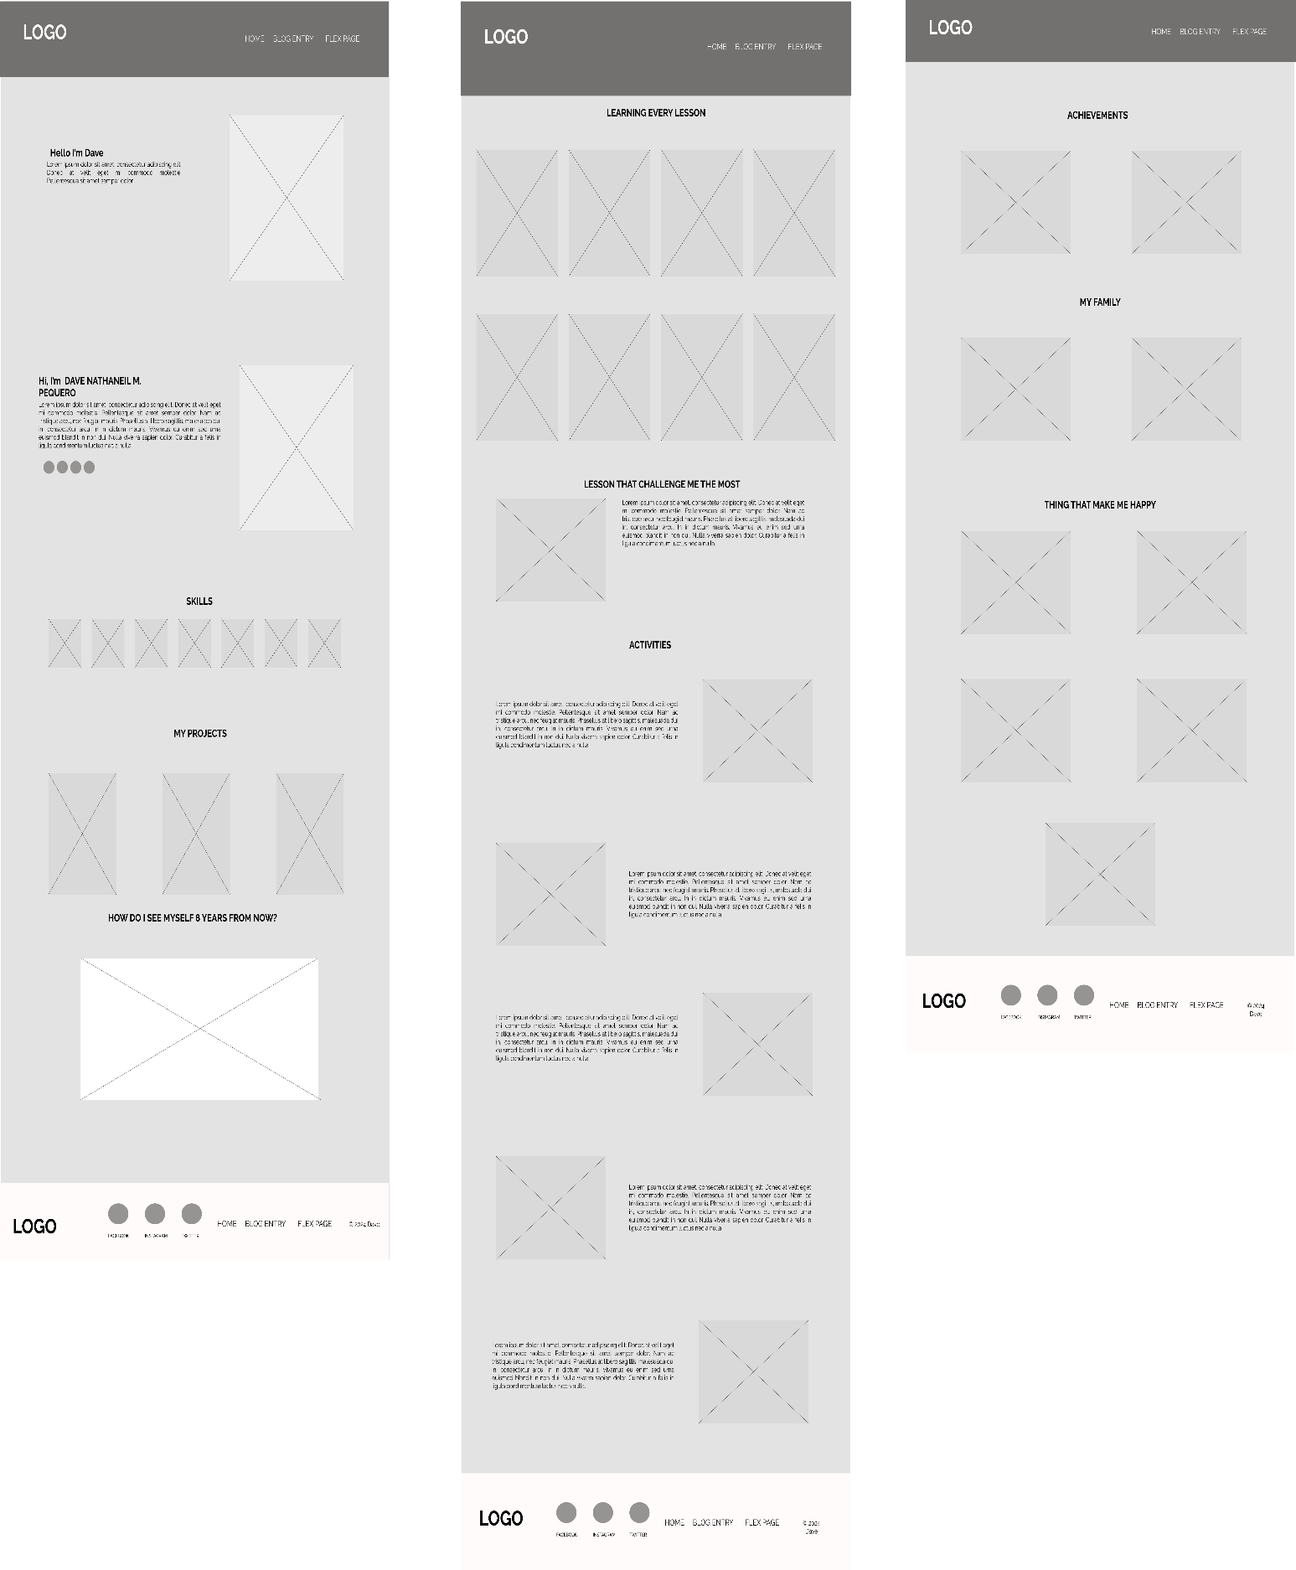Wireframes*

*Figure 1.3: Flex Page*

*Figure 1.1: Home Page*

*Figure 1.2: Blog Page*

*Web Design*

The portfolio website is aesthetically attractive and user-friendly. Using a light green-blue color scheme for the background of #DFF2EB creates a gentle and professional atmosphere. Deep purple accents (#7d2ae8) in the header, footer, and container shadows add sophistication, and dark gray text (#333) provides readability. Together, this color palette establishes a modern and engaging user experience.

Color

The rich purple highlights are elegant and draw attention to important aspects, while the calming light green-blue background makes a great foundation. Text in deep gray is easier to see and gives off a sleek, contemporary appearance.



#7D2AE8

# DFF2EB

# 333

*Figure 2.1: Selected Color Palette*

Typeface

The Montserrat typeface was selected because of its bold, modern appearance, which goes well with the website's simple, modern layout. This typeface guarantees that the website looks sleek and professional while also improving readability.

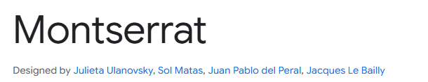

*Figure 2.2: Selected Typeface*

Icons

Icons were carefully chosen to maintain consistency throughout the site. They enhance the visual coherence and ensure a unified look, contributing to a seamless user experience. These icons represent skills, software, and social media links.



*Figure 2.3: Icon Variations*

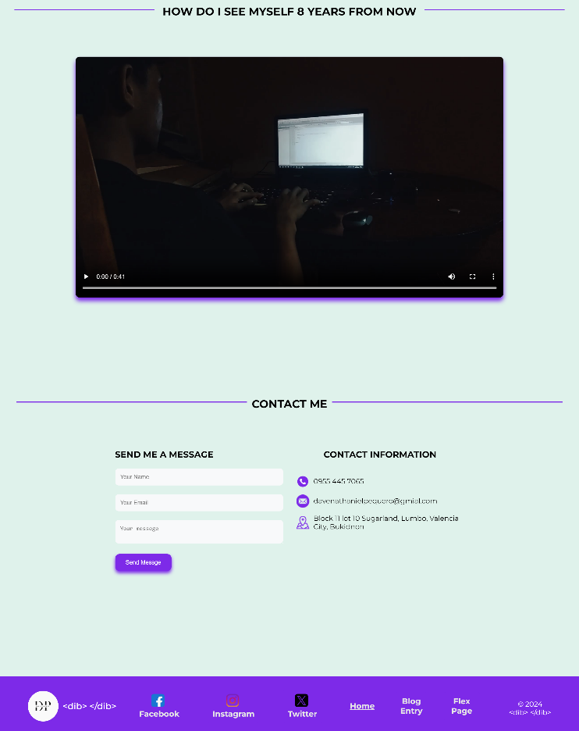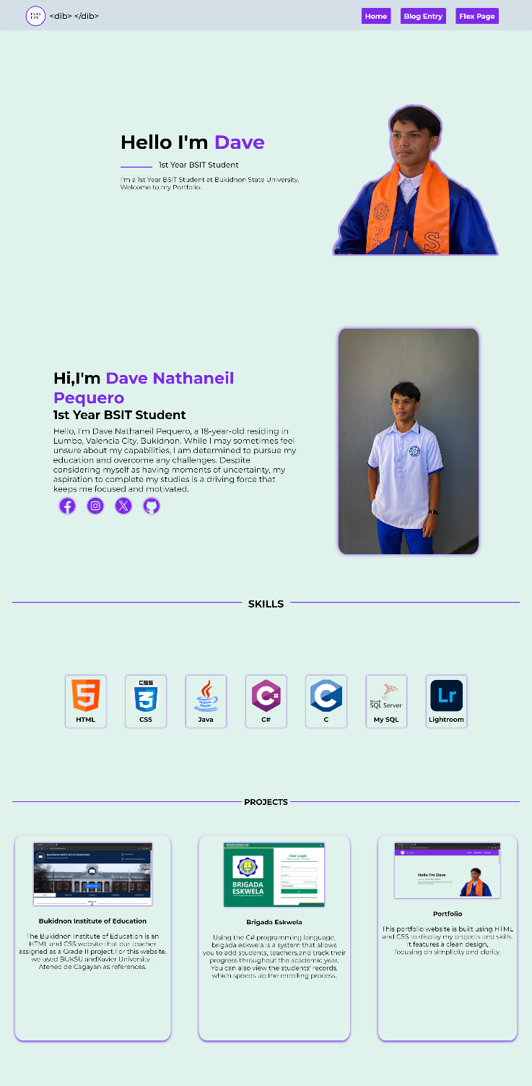

*Figure 3.1: Website design for Home Page*

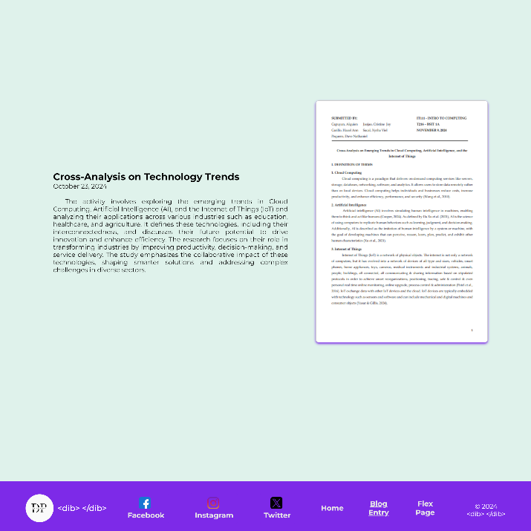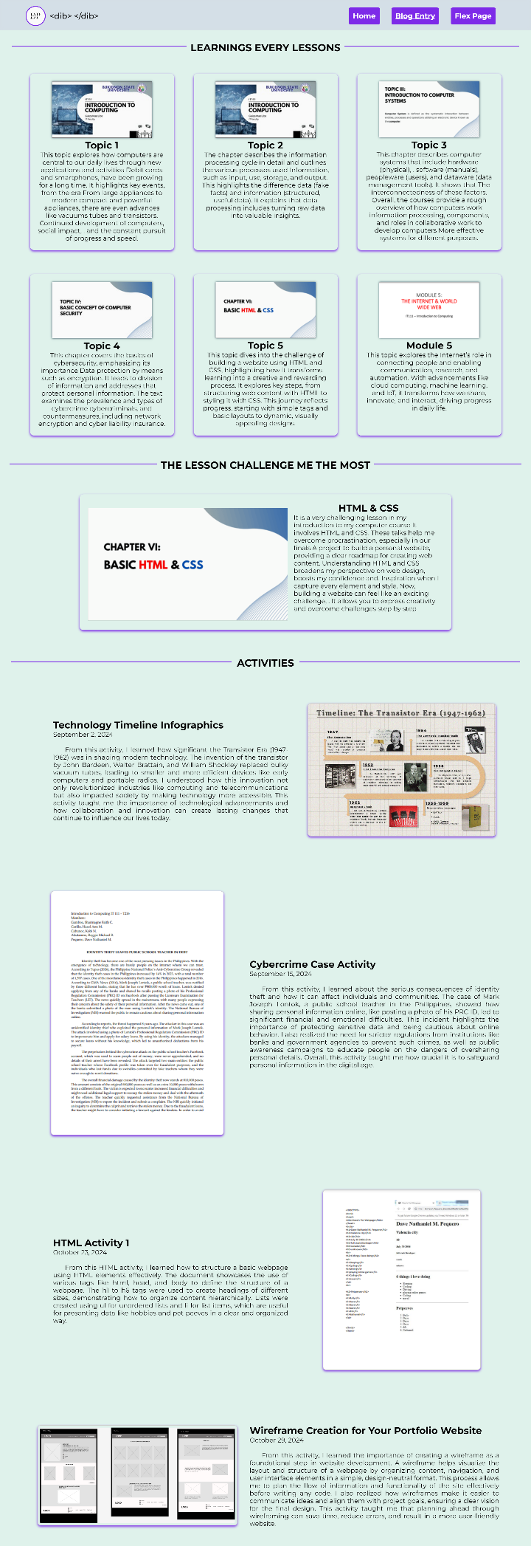

*Figure 3.2: Website design for Blog Page*

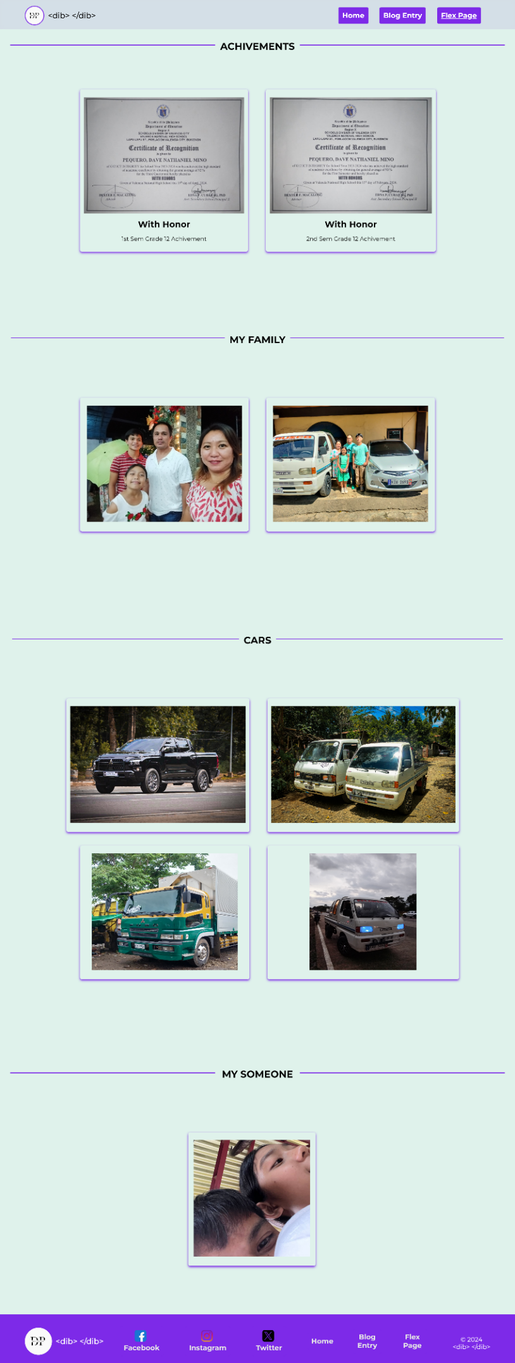

*Figure 3.3: Website design for Flex Page*

**Requirements**

*Domain Name*

The domain name for the website should follow the format LastName-FirstName-Section Code. This standardized structure ensures uniformity and efficient management across websites created by students from different sections. It also simplifies the identification of section affiliation and content authorship for administrators, peers, and instructors. For instance, the domain name for the website would be formatted as pequero-davenathaneil-t218.

*Hosting Plan*

The instructor recommended using Netlify, a platform offering free hosting services for static webpages. Netlify simplifies the deployment process with features like automatic deployment and free SSL certificates, making it an ideal choice for hosting portfolio websites.



*Figure 4: Netlify Logo*

*Technical Requirements*

To successfully deploy the website, students need to meet the following requirements:

1. **Finalized Website Files (HTML and CSS**): Ensure all files are complete and well-structured.
2. **Gmail Account**: Needed for account creation and communication with hosting and version control platforms.
3. **GitHub Account**: Required for managing the project’s codebase through version control.
4. **Netlify Account**: Essential for connecting the project to Netlify for deployment and hosting.
5. **Internet Connectivity**: Reliable access is necessary for file uploads, GitHub commits, and Netlify deployment.

**Account Setup**

*Creating an Account:*

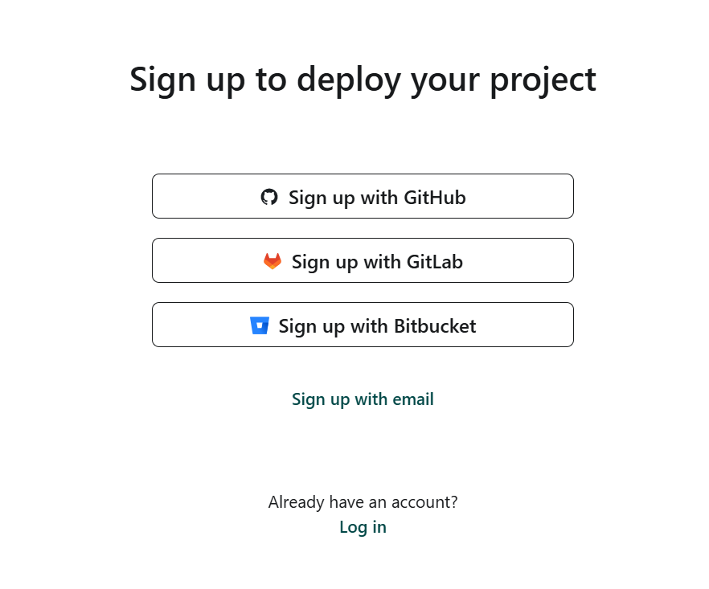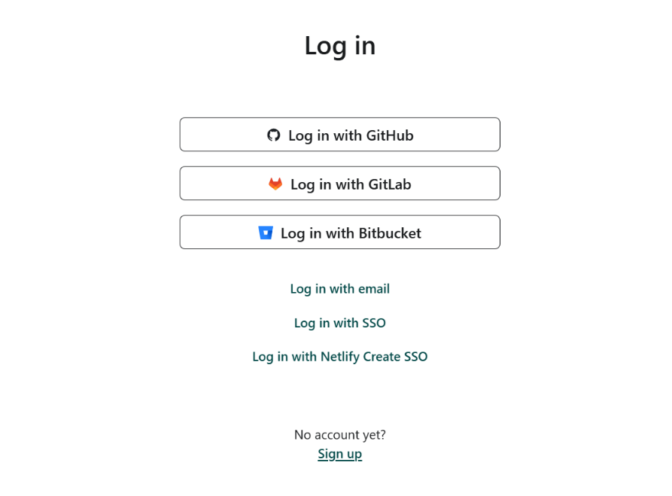

*Figure 5.1 : Clicking on the sign up link Figure 5.2: Sign up with GitHub*

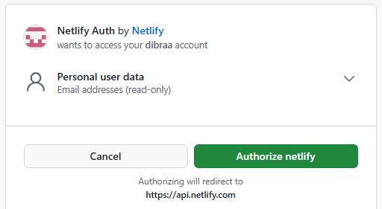

*Figure 5.3: Netlify authorization with GitHub user data*

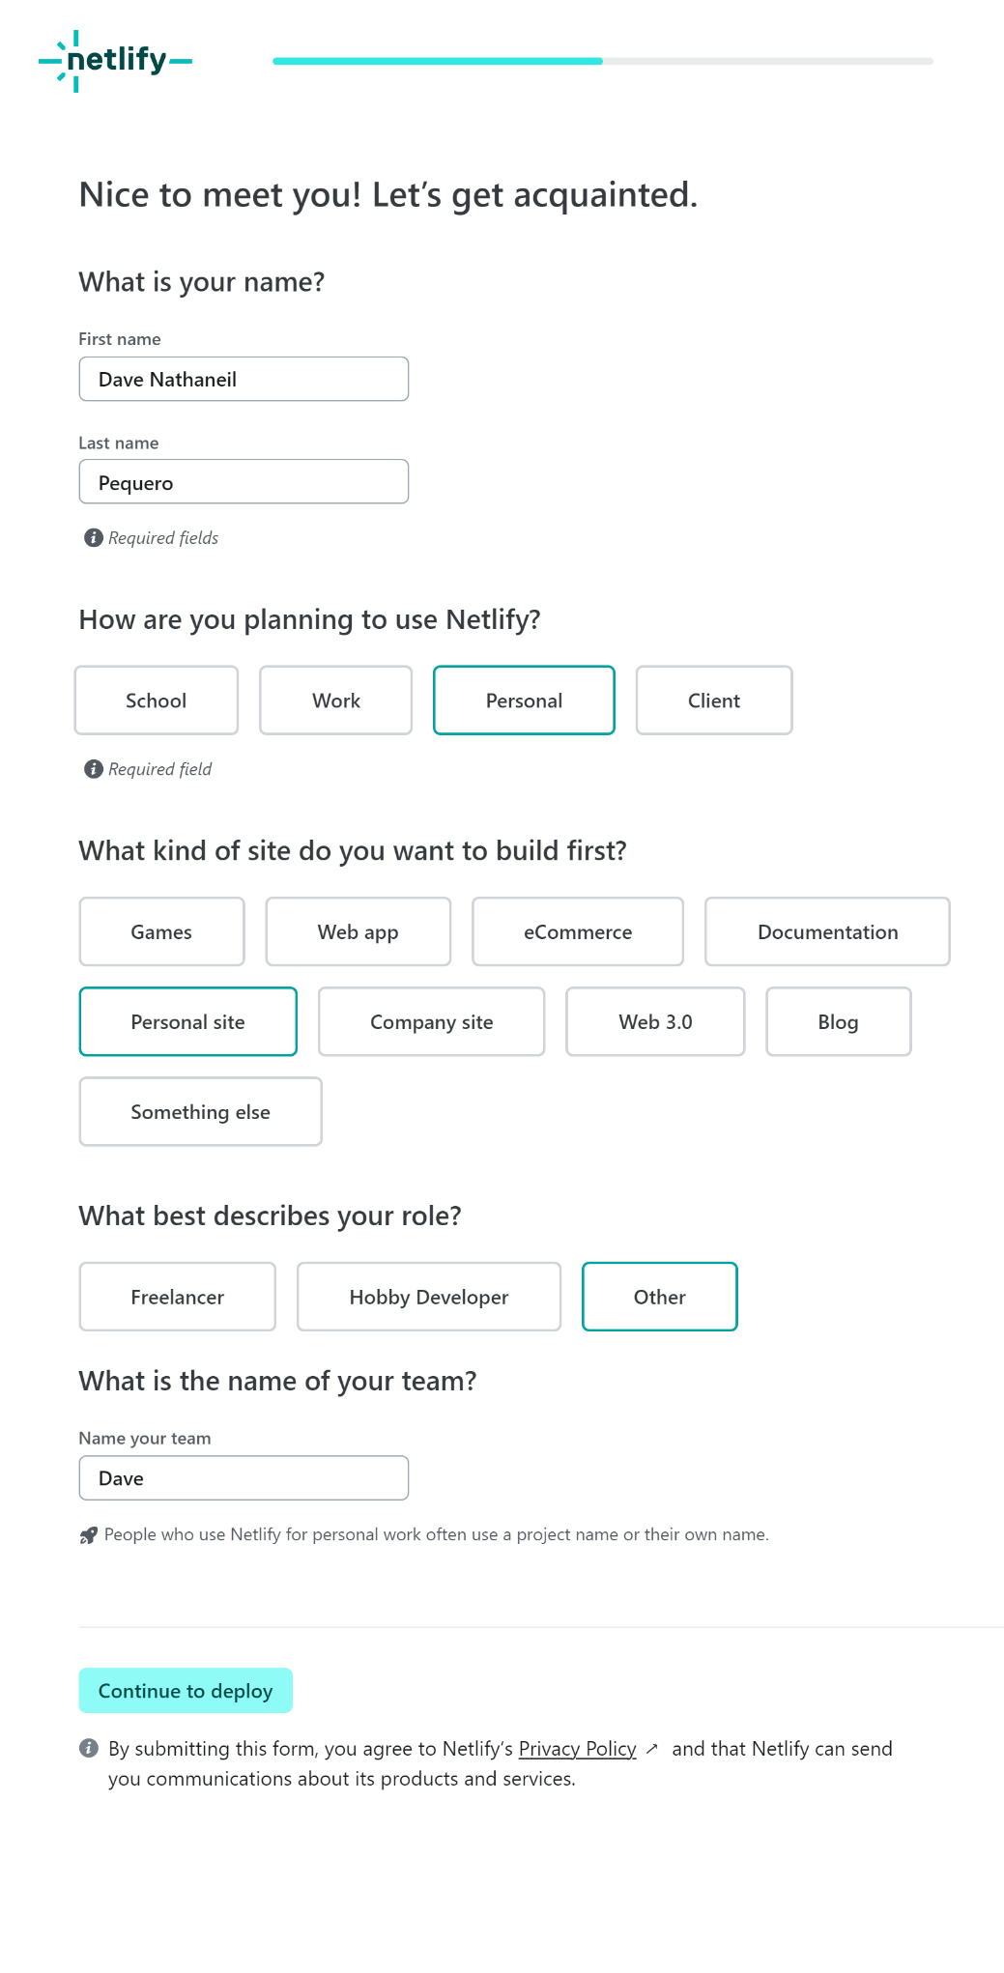

*Figure 5.4: Completing the Forms and Proceeding to Deployment*

*Logging In*

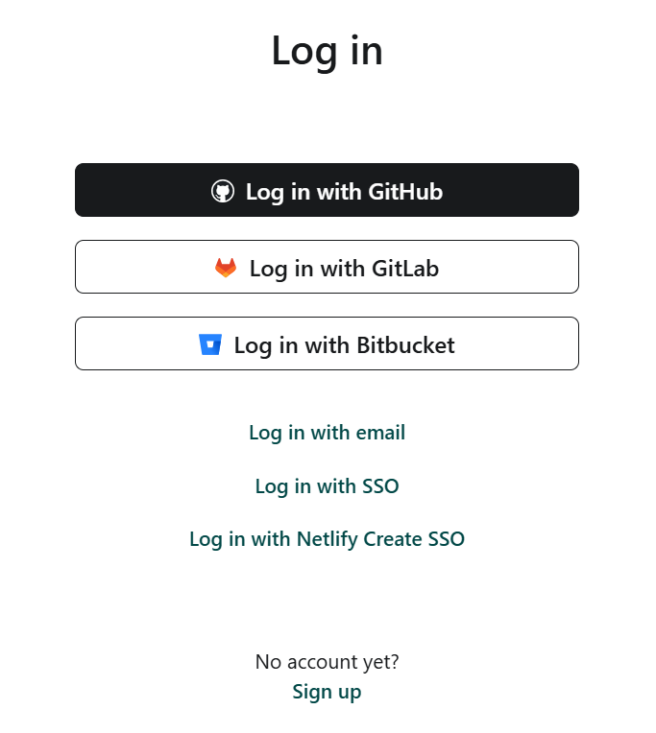

*Figure 6.1: Loggin with GitHub Account.*

*Domain Registration*

The student will not register any domains separately and will only utilize Netlify's free website hosting, which includes a built-in custom domain feature. This approach is more cost-effective for the course project since registering a domain would incur additional costs. Netlify provides an easy way to connect a custom domain to your site without the need for separate domain registration.

This setup simplifies the deployment and management of the portfolio website and aligns with the course requirements.

**Website Deployment**

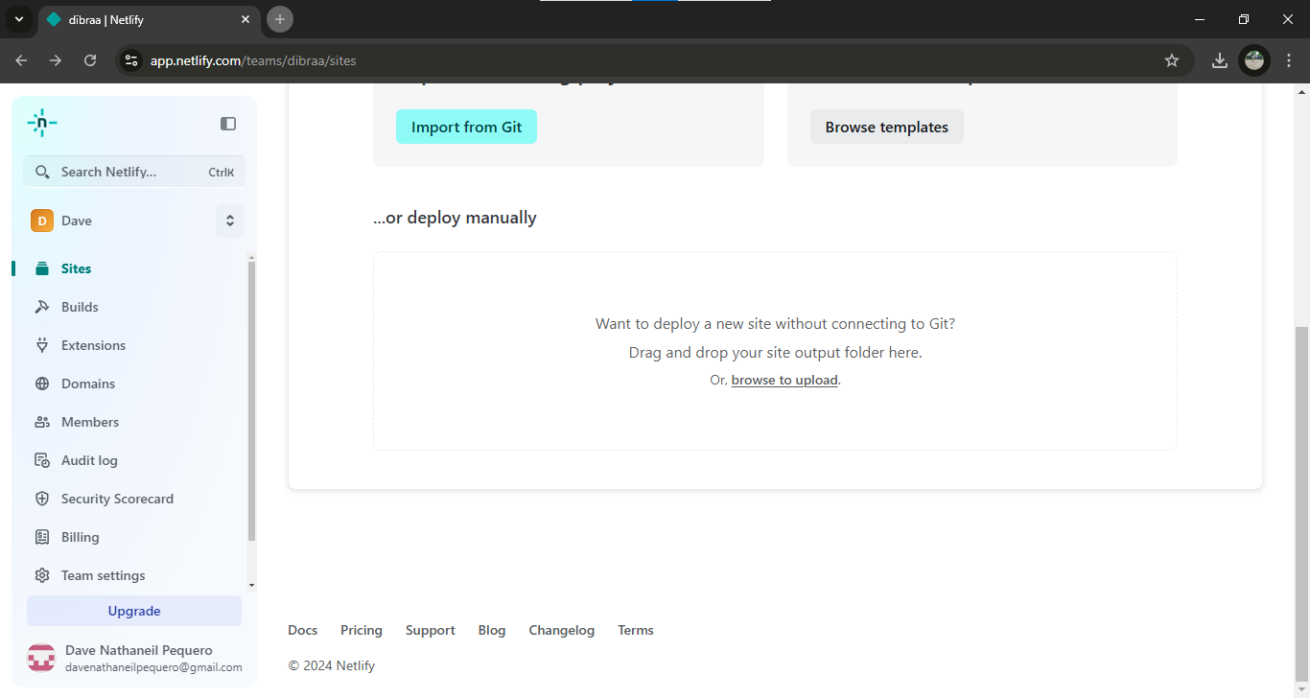*Uploading Files*

*Figure 7.1: Drag and drop the file or browse manually. Click on Upload and wait for the files to be uploaded.*

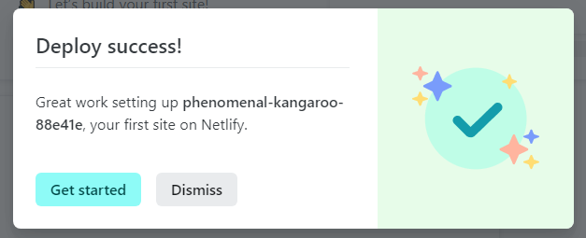

*Figure 7.2: Website deployment is successful*.

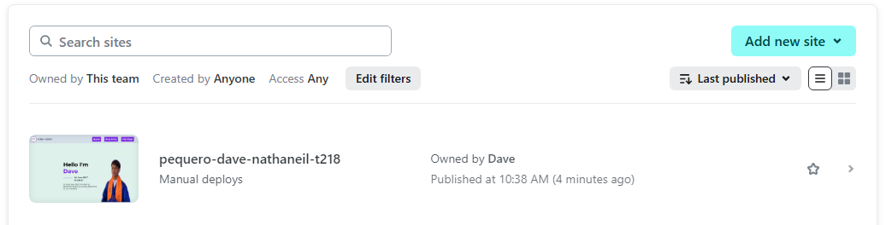

*Figure 7.3: The uploaded website will be shown here.*

*Discussion on the Web Deployment*

Netlify's simplicity makes it an accessible platform, even for beginners. The process begins with account creation and logging in, facilitated by integration with GitHub. The platform’s intuitive design allows users to connect version control, upload files, and deploy websites seamlessly.

Netlify's free hosting services include a built-in custom domain feature, removing the need for additional domain registration expenses. This convenience allows students to focus on creating and deploying their projects while gaining practical web development experience. Overall, Netlify's user-friendly tools ensure an efficient and educational deployment process.

**Conclusion**

*Summary*

This documentation provides a detailed guide on creating and deploying a personal portfolio website, covering every step from design to web hosting. The website includes three main pages: the **Home Page** (a welcoming introduction with personal insights and goals), the **Blog Page** (a space for documenting IT coursework and reflections), and the **Flex Page** (a creative outlet for showcasing achievements and projects).

Key technical requirements include finalized website files (HTML and CSS), a GitHub account for version control, and a Netlify account for hosting. Netlify, a free and user-friendly hosting platform, simplifies the deployment process by enabling students to upload files and generate a live link easily. The documentation outlines the account setup, logging in, and domain registration, highlighting the use of Netlify’s built-in custom domain feature for cost efficiency.

The deployment process is explained step-by-step, ensuring clarity for beginners. The website design emphasizes aesthetics and readability, with a modern color palette, consistent typeface, and thoughtfully chosen icons. This project demonstrates practical skills in web development and hosting while fostering creativity and self-expression.

Finally, the conclusion reflects on the overall learning experience, reinforcing the importance of accessible tools like Netlify for empowering students to create and publish their work effectively.

*Personal Reflection/Opinion*

Creating this web documentation has been an insightful experience that helped me develop essential skills in web development. As a first-year IT student, this project allowed me to apply the concepts I’ve learned in class, such as designing webpages, understanding hosting platforms, and managing deployment processes. It also deepened my understanding of how to effectively present information in a clear and organized manner.

One of the most valuable aspects of this project was using Netlify for hosting. It demonstrated how accessible and efficient modern web development tools can be, especially for beginners like me. Setting up the account, linking it to GitHub, and deploying the website taught me the importance of version control and automation in real-world projects. These are skills I can carry forward in future coursework and professional endeavors.

I also appreciated the creative freedom this project provided. Designing the portfolio gave me the opportunity to showcase my skills and achievements while experimenting with colors, typefaces, and layouts. At the same time, documenting the process improved my ability to write structured, technical content, which is an essential skill in IT.

Overall, this project reinforced my passion for technology and web development. It was not without its challenges like debugging errors but overcoming these obstacles was a rewarding learning experience. This documentation is more than just a guide it reflects my journey and growth as an aspiring IT professional.

**References**

Netlify. (n.d.). Netlify: Develop & deploy the modern web. Retrieved December 11, 2024, from <https://www.netlify.com/>

GitHub. (n.d.). *GitHub: Where the world builds software*. Retrieved December 11, 2024, from <https://github.com/>